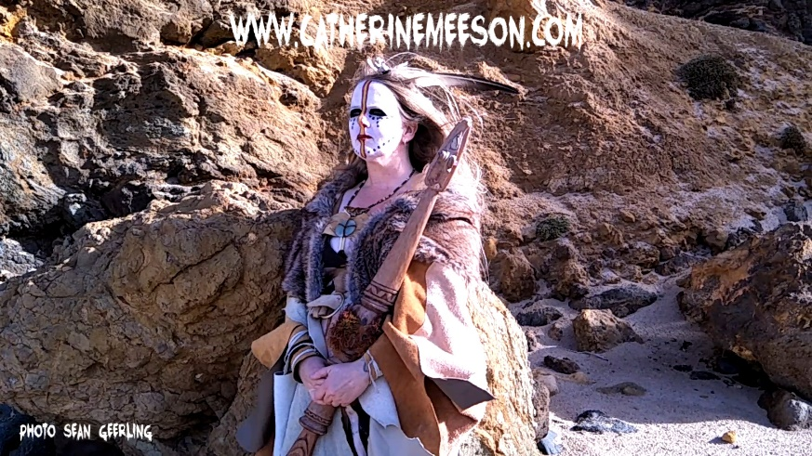
CATHERINE MEESON ARTIST BIOGRAPHY
Catherine began song writing in high school. She was given her first guitar at 13 and is mostly self-taught, refining her skills with a few lessons in later years. She is both a singer songwriter and an electronic composer. After returning to study and getting acquainted with music technology she was able to realize her musical desires with computers, software and analogue and electronic instruments. In the last decade she has honed her sound and written a lot of work. Stylistically it captures many essences, she defines it as ethereal wave, electro, & electro folk/ rock. Catherine’s music has been described as “atmospheric”, “otherworldly”, “ethereal”, “relaxing”, “trancy”, “cinematic journey music”, “like nothing else- unique,” “like being in an omnisphere travelling round the universe” “immersive and spacey” “mysterious ambience- portal to another world” “dynamic, rising and falling through seasons from organic folk-infused ambience to strong synthetic beats and luscious guitar textures” “like a musical goddess” “A valuable cool and transcendent ride” “Ceremonial psychedelic ritualistic journey into the deep recesses of the mind”. Guitar and vox has been said “Like PJ Harvey on acid” “Like nothing else, unique” “Definitely ambient” “like Kate Bush, Patti Smith & Annie Lennox” “Enchanting” & with “Metaphysical Melodies”.
In her music one can hear elements of old English folk, pop, electronic synthesizer music, rock tinges, progressive 70’s, ambient, minimalism, new age, 80’s & 90’s Indie and alternative influences, and even operatic tinges. Others have referred to it as “progressive cinematic indie rock” and “synth prog, or progressive electronic, gothic and folk pop”, even early 4AD such as Cocteau Twins. Catherine composes both songs and instrumental soundscapes. Lyrical themes include environmental matters, spirituality, relationships, mythos, story, politics and sacred activism, with shades of light, dark and all in between. At times, melancholic leanings and existential angst can also be heard, clothed in metaphor. She has released 3 albums to date Revolution Complete, Atmospherica, Contemplating Buddha and an ep length soundscape work Oriental Temple Gardens Complex. She has released a few singles Mr Big Man a power punch protest song and I Am (Song of The Earth) also off the forthcoming ‘The Call of Oma’ album due for release in 2019. Released on the Sonic Sanctuary label.
She is also a performance artist, working in the ritualistic, spiritual and sacred activist realms, exploring archetypal themes and contemporary mythos in sacred theatre. To this affect she has done multiple performances as The Beggar Woman and made a site-specific movie, performed as Grace in Grace and the Grail, and as both the Bodhisattva and The Minister from the Imperial court of Weights and Measures, in her first solo play By the Mandate of Heaven. She has also produced a dvd of Studio Sessions detailing her creative process over two albums. She writes poetry, prose and when compelled makes visual art works. Her interest is expanding into film as a complete synthesis of all art forms. Catherine has performed at open mics, festivals, Melbourne venues and fundraisers, and as a charity gifting. She is active as an artist in the community teaching Music Drama and creative arts, and works in community arts practice exploring social transformation/ arts health with Creative Arts therapies.
‘Come Back’ the cinematic epic electro orchestral work and film clip will be released on ‘World Oceans Day’ June 8th 2019.A Youtube release only, pre cursor to the album ‘The Call of Oma’. Crowdfund coming soon.
CATHERINE MEESON –SINGER SONGWRITER/ COMPOSER /PRODUCER/ PERFORMANCE ARTIST
Phone - 0421 850 297 catherine.meeson.cm@gmail.com
OFFICIAL WEBSITE - www.catherinemeeson.com
YOUTUBE - http://www.youtube.com/user/CatherineMeeson/videos
FACEBOOK - http://www.facebook.com/CatherineMeesonMusic
INSTAGRAM - https://www.instagram.com/catherinemeesonmusic/
BANDCAMP- http://catherinemeeson.bandcamp.com/

